**DAILY ONLINE ACTIVITIES SUMMARY**

|  |  |  |  |  |  |  |  |
| --- | --- | --- | --- | --- | --- | --- | --- |
| **Date:** | **26-06-2020** | | | | **Name:** | **B.A.SOHANKUMAR** | |
| **Sem & Sec** | **4TH SEM A** | | | | **USN:** | **4AL18CS013** | |
| **Online Test Summary** | | | | | | | |
| **Subject** | | **----** | | | | | |
| **Max. Marks** | | **----** | | **Score** | | **----** | |
| **Certification Course Summary** | | | | | | | |
| **Course** | **BLOCKCHAIN BASICS** | | | | | | |
| **Certificate Provider** | | | **GLA** | **Duration** | | | **2.5 HOURS** |
| **Coding Challenges** | | | | | | | |
| **Problem Statement: Given start and end of a range, write a python program to print all negative numbers in a given range.** | | | | | | | |
| **Status:EXECUTED** | | | | | | | |
| **Uploaded the report in Github** | | | | **YES** | | | |
| **If yes Repository name** | | | | **LOCKDOWN CODING** | | | |
| **Uploaded the report in slack** | | | | **YES** | | | |

**CERTIFICATION COURSE DETAILS:**

Course: BLOCKCHAIN BASICS

Completed modules today are Consensus Mechanism,Proof of work and stake,Mechanism of Blockchain Transaction,Blockchain Ecosystem,Why Industries Need Blockchain, Industry Challenges For Blockchain Adoption,Blockchain Examples and successfully completed the course.

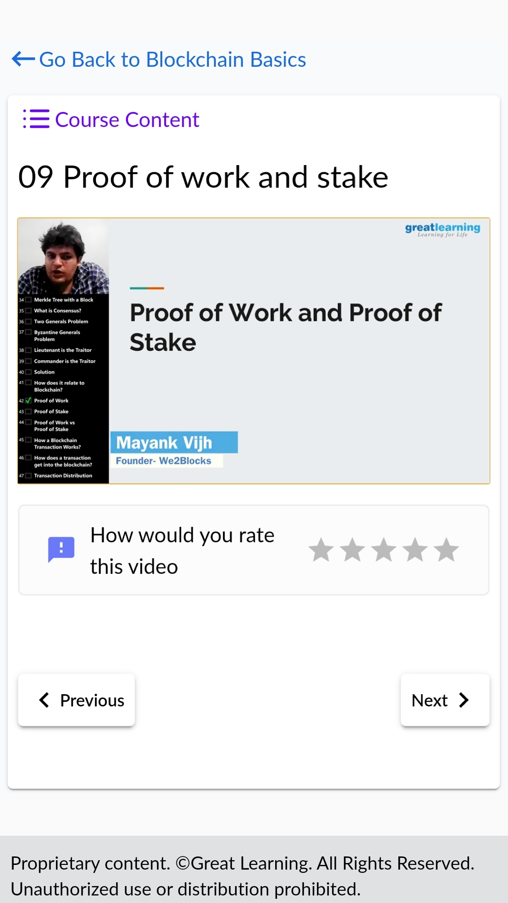 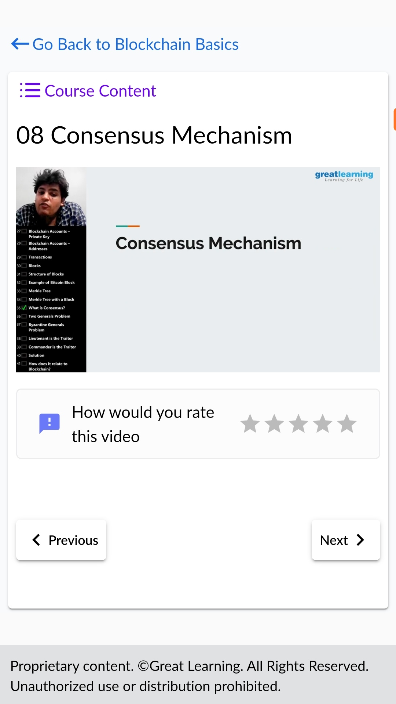

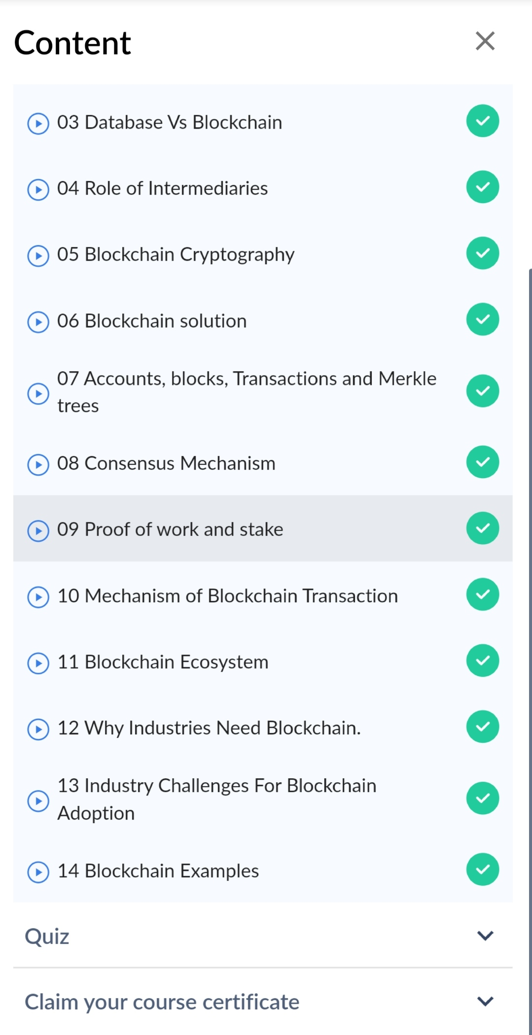COMPLETED MODULES

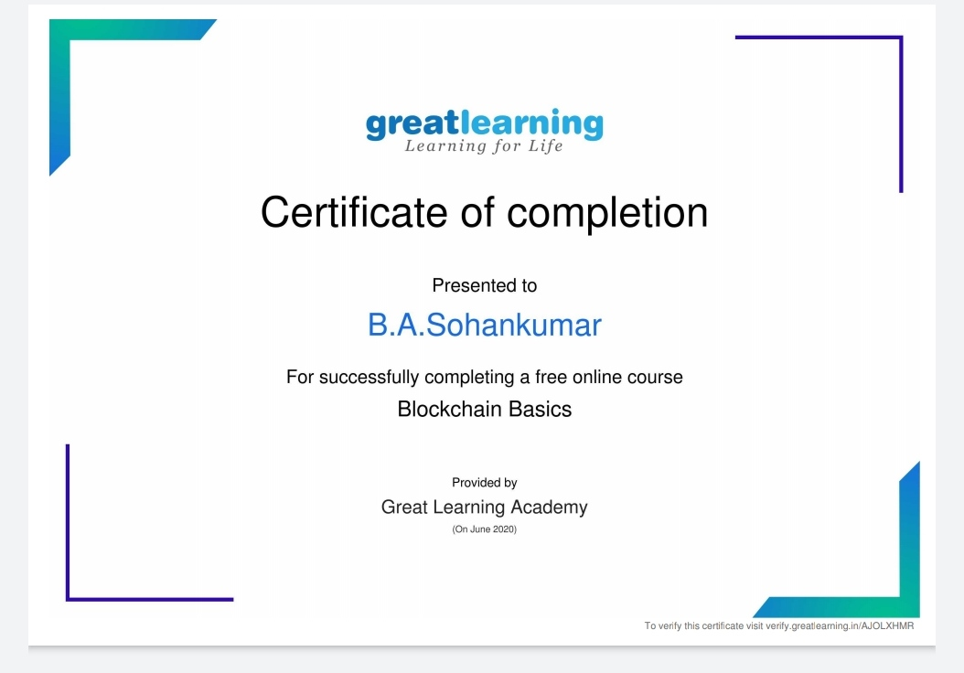

Above certificate is awarded for the completion of the course.

**CODING CHALLENGES DETAILS:**

1. Given start and end of a range, write a Python program to print all negative numbers in given range.

Example: Input: start = -4, end = 5 Output: -4, -3, -2, -1 Input: start = -3, end = 4 Output: -3, -2, -1

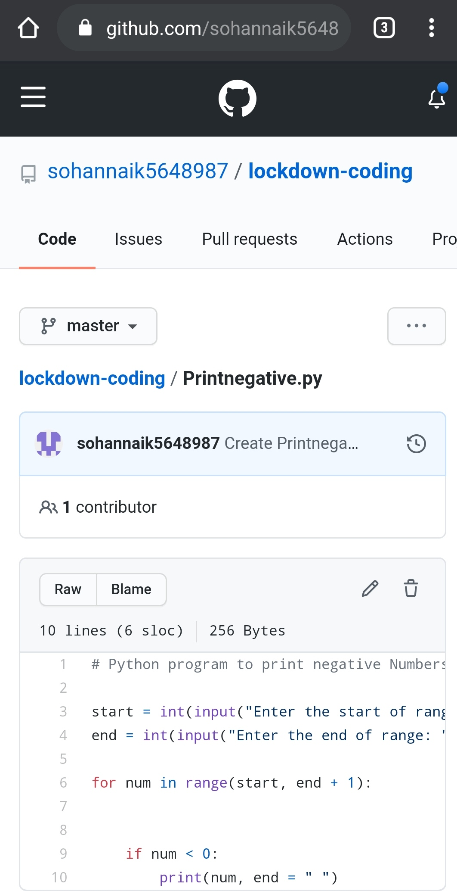

REPOSITORY LINK:https://github.com/sohannaik5648987/lockdown-coding